web_infrastructure_design

2. Secured and monitored web infrastructure

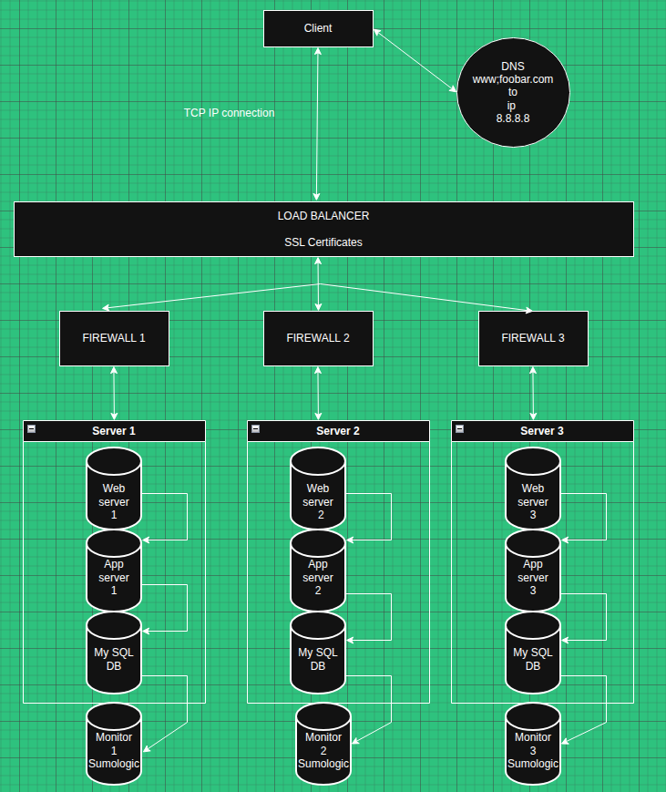

- What are firewalls for
Firewalls filter incoming and outgoing network trafic and blocks the unautorzied access and protects the network from the attacks

- Why is the traffic served over HTTPS
- HTTPS encrypts data between client and server, prevents eavesdropping, ensures data integrity, and authenticates the server to prevent man-in-the-middle attacks.

- What monitoring is used for
The monitoring allows to track the performance of the hardware (hdd, ram cpu load) and the software(application performance), it detects failures and send alerts

- How the monitoring tool is collecting data
Monitoring agents installed on each server collect system metrics, application logs, and performance data, then transmit this information to centralized monitoring services like Sumologic

- Explain what to do if you want to monitor your web server QPS
Parse Nginx access logs to count requests per second, use monitoring tools with HTTP request tracking, or implement application-level counters that measure query frequency.

You must be able to explain what the issues are with this infrastructure:

- Why terminating SSL at the load balancer level is an issue
Creates unencrypted HTTP traffic between load balancer and servers, exposing internal network to potential attacks

- Why having only one MySQL server capable of accepting writes is an issue
- Primary database remains a SPOF for write operations - application cannot save data if it fails
- Why having servers with all the same components (database, web server and application server) might be a problem
Web server, application server, and database compete for resources on the same hardware

